**BuildRoot – use external cross compiler**

This document is based on the Cross tool ng.docx

Download build root and set config for example from raspberry pi 3

Make raspberrypi3_defconfig

Set the toolchain type to External toolchain

And custom toolchain

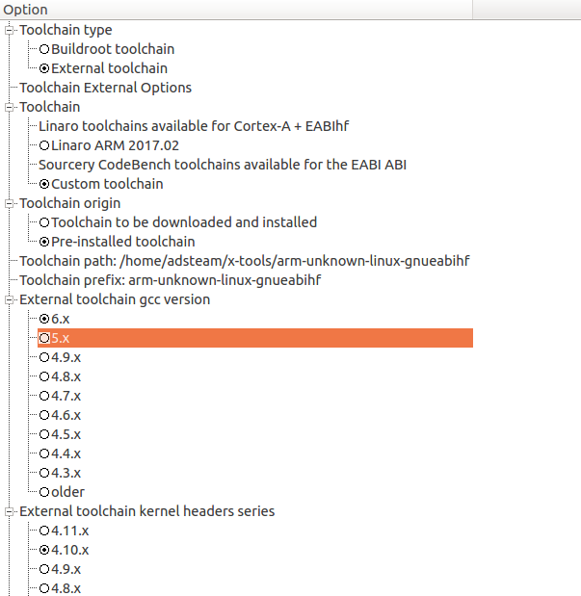

I previously downloaded, configured and installed using crosstool-ng a compiler for hardware floating point (HF)

The compiler path is specified in toolchain path

The prefix is the name of the compiler without the g++ or gcc , it is called the prefix

Or the – at the end

The prefix: arm-unknown-linux-gnueabihf

We can run

./arm-unknown-linux-gnueabihf-g++ -v

To see the version and more about the compiler

Using built-in specs.

COLLECT_GCC=./arm-unknown-linux-gnueabihf-g++

COLLECT_LTO_WRAPPER=/home/adsteam/x-tools/arm-unknown-linux-gnueabihf/libexec/gcc/arm-unknown-linux-gnueabihf/6.3.0/lto-wrapper

Target: arm-unknown-linux-gnueabihf

Configured with: /home/adsteam/toolchains/ARM/.build/src/gcc-6.3.0/configure --build=i686-build_pc-linux-gnu --host=i686-build_pc-linux-gnu --target=arm-unknown-linux-gnueabihf --prefix=/home/adsteam/x-tools/arm-unknown-linux-gnueabihf --with-sysroot=/home/adsteam/x-tools/arm-unknown-linux-gnueabihf/arm-unknown-linux-gnueabihf/sysroot --enable-languages=c,c++ --with-float=hard --with-pkgversion='crosstool-NG crosstool-ng-1.23.0' --disable-sjlj-exceptions --enable-__cxa_atexit --disable-libmudflap --disable-libgomp --disable-libssp --disable-libquadmath --disable-libquadmath-support --disable-libsanitizer --disable-libmpx --with-gmp=/home/adsteam/toolchains/ARM/.build/arm-unknown-linux-gnueabihf/buildtools --with-mpfr=/home/adsteam/toolchains/ARM/.build/arm-unknown-linux-gnueabihf/buildtools --with-mpc=/home/adsteam/toolchains/ARM/.build/arm-unknown-linux-gnueabihf/buildtools --with-isl=/home/adsteam/toolchains/ARM/.build/arm-unknown-linux-gnueabihf/buildtools --enable-lto --with-host-libstdcxx='-static-libgcc -Wl,-Bstatic,-lstdc++,-Bdynamic -lm' --enable-threads=posix --enable-target-optspace --enable-plugin --enable-gold --disable-nls --disable-multilib --with-local-prefix=/home/adsteam/x-tools/arm-unknown-linux-gnueabihf/arm-unknown-linux-gnueabihf/sysroot --enable-long-long

Thread model: posix

**gcc version 6.3.0** (crosstool-NG crosstool-ng-1.23.0)

so we set the version : 6.3.0

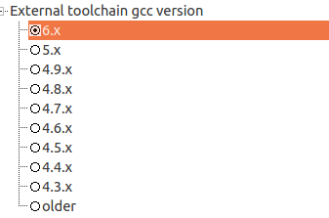

You will probably get the following errors:

1. The kernel headers are not matched – change in case you need
2. The external tool chain library, to which it was compiled with glibc , musl or uclibc
3. In case it was compiled with RPC OR SSP you need to mark it

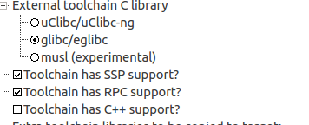

We can save and run make